**Unity project Files**

* **Located at** [gargaroots/Torkbuster (github.com)](https://github.com/gargaroots/Torkbuster)

**To run the app locally**

* Download WampServer (<https://sourceforge.net/projects/wampserver/files/latest/download>)
* Install WampServer
* Open WampServer
* Click the WampServer icon on the Taskbar
* 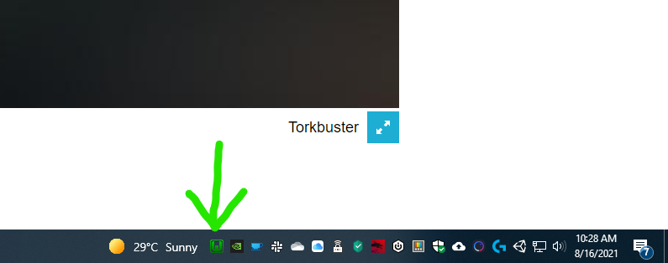

* Select "www directory"
* 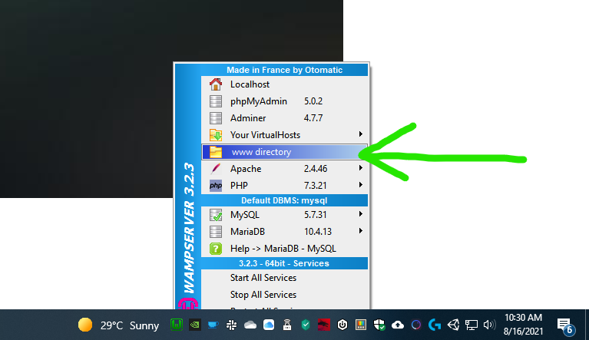

* A Windows Explorer window will open. Extract the .zip file here.
* 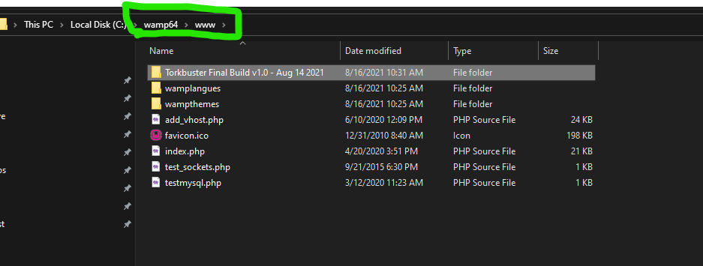

* Now click the WampServer icon again, and select "Your VirtualHosts -> VirtualHost Management"
* 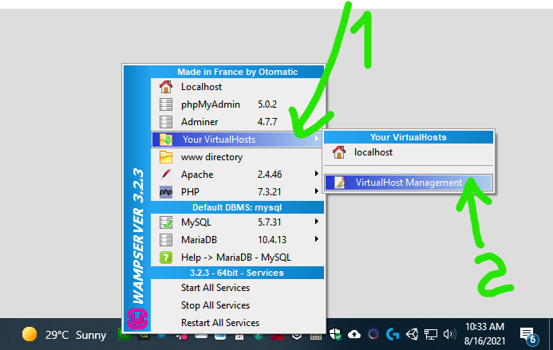

* A web browser will open. Fill in the required fields and press "Start the creation of the VirtualHost"
* 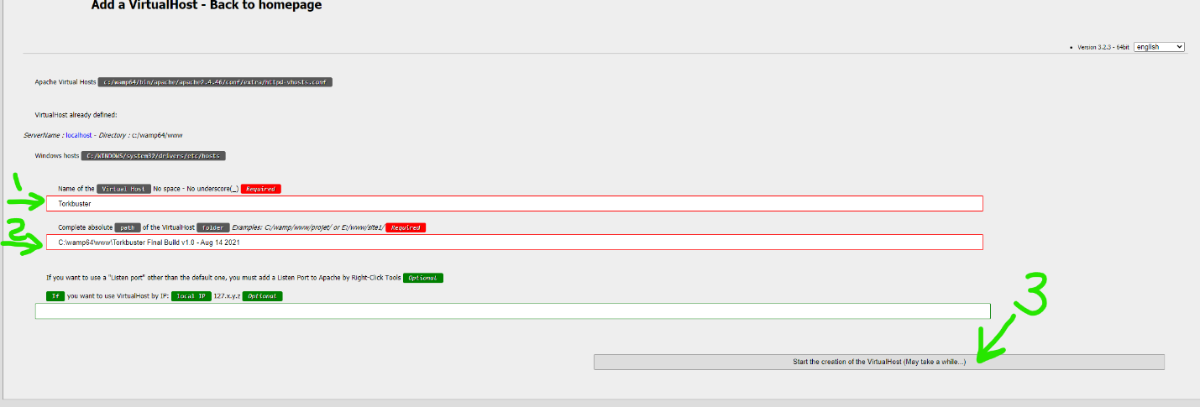

* Now **right-click** the WampServer icon on the Taskbar and select "Tools -> Restart DNS"
* 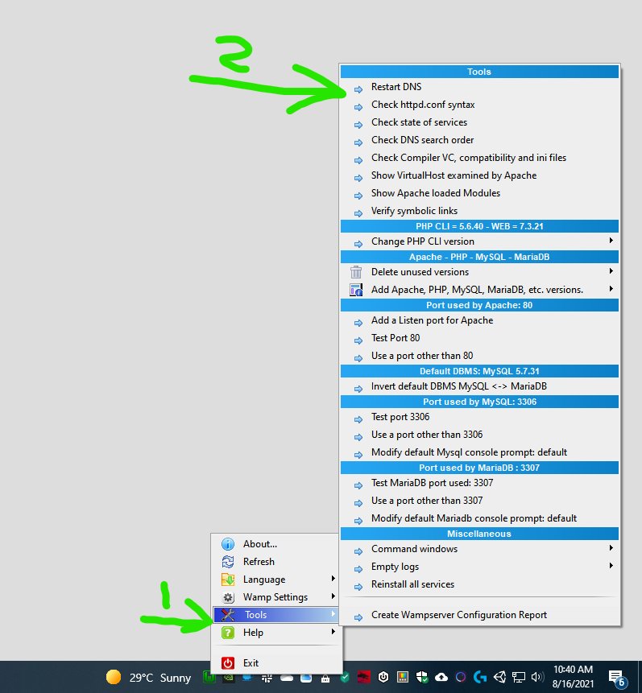

* Wait a few seconds until the icon turns green again and click it, go to "My VirtualHosts -> Torkbuster" and the app will run
* 